**Insurance Database**

**Question**

**(Week 01)**

**-** PERSON (driver_id: String, name: String, address: String)

**-** CAR (reg_num: String, model: String, year: int)

**-** ACCIDENT (report_num: int, accident_date: date, location: String)

**-** OWNS (driver_id: String, reg_num: String)

**-** PARTICIPATED (driver_id: String,reg_num: String, report_num: int, damage_amount: int)

**-** Create the above tables by properly specifying the primary keys and the foreign keys. **-** Enter at least five tuples for each relation

**-** Display Accident date and location

**-** Update the damage amount to 25000 for the car with a specific reg_num (example 'K A031181' ) for which the accident report number was 12.

**-** Add a new accident to the database.

**-** To Do

**-** Display Accident date and location

**-** Display driver_id who did accident with damage amount greater than or equal to Rs.25000

**Schema Diagram**

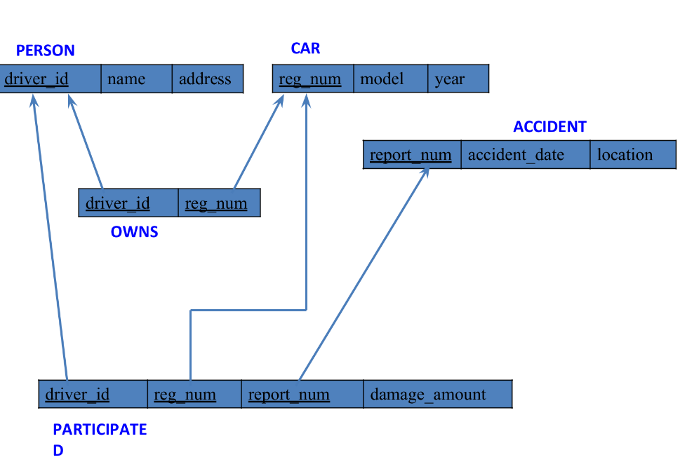

**Create database**

**create database** insurances_402;

**use** insurances_402;

**Create table**

**create table** person(

driver_id varchar(3) **primary key,**

namevarchar(20) **not null**,

address varchar(100)

);

**create table** car(

reg_no char(8) **primary key,**

model varchar(20),

yearint(4) **not null**

);

**create table** accident(

report_no int(4) **primary key,**

accident_date date,

location varchar(100)

);

**create table** owns(

driver_id varchar(3),

reg_no char(8),

**foreign key**(driver_id) **references** person(driver_id),

**foreign key**(reg_no) **references** car(reg_no)

);

**create table** participated(

driver_id varchar(3),

reg_no char(8),

report_no int(4),

damage_amt int,

foreign **key**(driver_id) **references** person(driver_id),

foreign **key**(reg_no) **references** car(reg_no),

foreign **key** (report_no) **references** accident(report_no)

);

**Person table :**

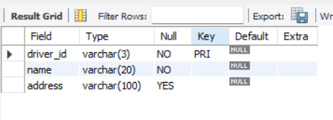

**Car table :**

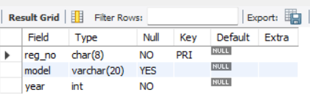

**Accident table :**

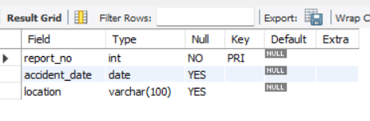

**Owns table :**

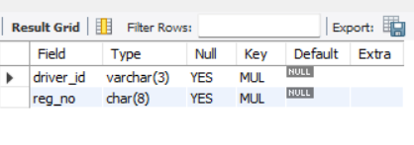

**Participated table :**

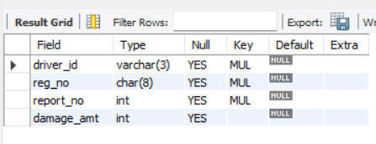

**Inserting Values into the table**

insert into person values("A01","kusuma", "tyagaraj nagar");

insert into person values("A02","salma", " M K nagar");

insert into person values("A03","jayshree", "Ashok nagar");

insert into person values("A04","chintu", "Naa Roai Colony");

insert into person values("A05","Johnn", "hanumanth nagar");

**select \*** from person;

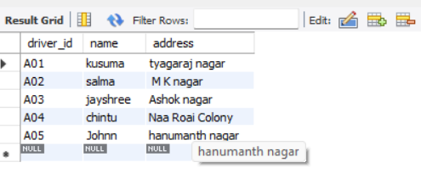

insert into car values("KA052250","Indica", "1990");

insert into car values("KA031181","Lancer", "1957");

insert into car values("KA095477","Toyota", "1998");

insert into car values("KA053408","Honda", "2008");

insert into car values("KA041702","Audi", "2005");

**select \*** from car;

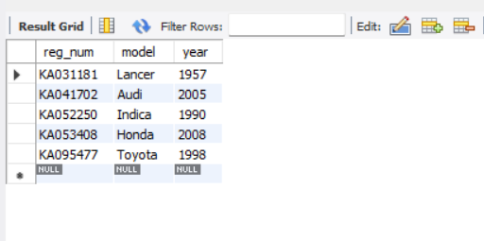

insert into owns values("A01","KA052250");

insert into owns values("A02","KA031181");

insert into owns values("A03","KA095477");

insert into owns values("A04","KA053408");

insert into owns values("A05","KA041702");

**select \*** from owns;

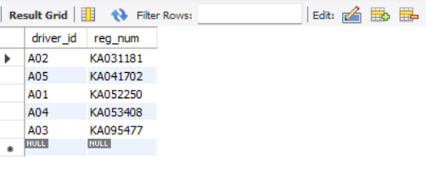

insert into accident values(11,'2001-01-01',"Mysore Road");

insert into accident values(12,'2002-02-02',"South end Circle");

insert into accident values(13,'2003-01-21',"Bull temple Road");

insert into accident values(14,'2004-12-17',"Mysore Road");

insert into accident values(15,'2005-03-05',"Kanakpura Road");

select * from accident;

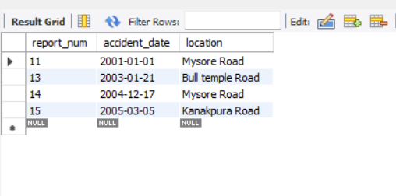

insert into participated values("A01","KA052250",11,10000);

insert into participated values("A02","KA053408",12,50000);

insert into participated values("A03","KA095477",13,25000);

insert into participated values("A04","KA031181",14,3000);

insert into participated values("A05","KA041702",15,5000);

**select \*** from participated;

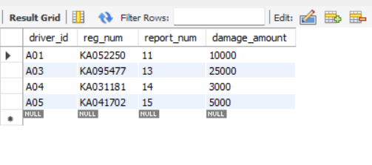

**Queries**

**- Update the damage amount to 25000 for the car with a specific reg-num (example 'KA053408' ) for which the accident report number was 12.**

**update** participated **set** damage_amount=25000 **where** reg_num='KA053408' and report_num=12;

select * from participated;

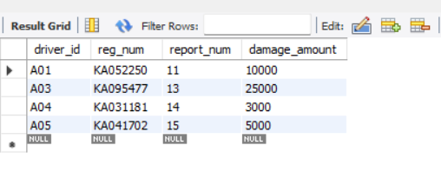

**- Find the total number of people who owned cars that were involved in accidents in 2008.**

**select** count(distinct driver_id) CNT from participated a, accident b **where** a.report_num=b.report_num and b.accident_date like '2001%';

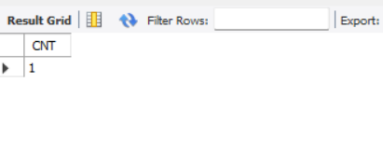

**- Add a new accident to the database.**

insert into accident values(16,'2003-03-08',"Domlur");

select * from accident;

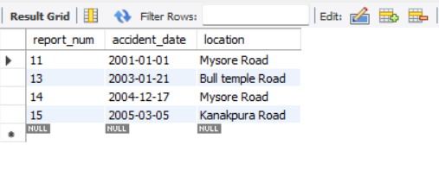

**TO DO:**

**● DISPLAY ACCIDENT DATE AND LOCATION**

**select** accident_date **as** date, location **from** accident;

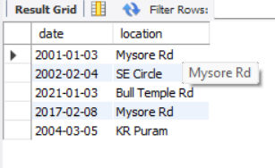

**● DISPLAY DRIVER ID WHO DID ACCIDENT WITH DAMAGE AMOUNT GREATER THAN OR EQUAL TO RS.25000**

**Select** participated.driver_id as driver_id from accident,participated **where** accident.report_no = participated.report_no and participated.damage_amt >= 25000;

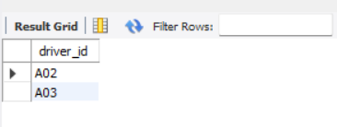

S